**Experiment -2.2**

**Student Name:** Parikshit sharma **UID:** 19BCS4520

**Branch:** CSE IOT **Section/Group:**1-A

**Semester**: 4th **Date of Performance:**29/03/2021

**Subject Name :** Project based learning in java  **Subject Code:**CSP-296

**Aim/Overview of the practical:**

Write a Program to perform the basic operations like insert, delete, display and search in list. List contains String object items where these operations are to be performed.

**2. Task to be done:**

* Appand
* Add items to an existing list.
* Remove the elements from the list.
* Display the list.
* Search for an element in the list**.**
* Find particular letter to search

1. **Apparatus(For applied/experimental sciences/materials based labs):**

NetBeans

**4. Algorithm/Flowchart (For programming based labs):**

STEP 1: Create a class named Alist.

STEP 2: Create a list and initialize it with the elements.

STEP 3: Display the menu to the user for append,insert, removing , displaying the list, and find particular .

STEP 4: Perform all the operations using the inbuilt functions add(), remove(), iterator() and contains().

STEP 5 :Exit.

**5. Theme/Interests definition( For creative domains):**

* The ArrayList class is a resizable array, which can be found in the java.util package.
* It has add() to add element , remove() to delete element from the list , Iterator() to print the elements , contains() to check if an item is present in the list and many more.

**6. Steps for experiment/practical:**

/*

* To change this license header, choose License Headers in Project Properties.

* To change this template file, choose Tools | Templates

* and open the template in the editor.

*/

package ex5_arraylist_insert_append_search;

/**

*

* @author dell

*/

import java.util.Scanner;

import java.util.ArrayList;

import java.util.Iterator;

/**

*

* @author dell

*/

public class AList

{

Scanner sc;

String str;

public void append(ArrayList AL)

{

char ans;

do

{

System.out.println("Enter the student name:");

sc = new Scanner(System.in);

str=sc.next();

AL.add(str);

System.out.println("Do u wanna append more student");

ans=sc.next().charAt(0);

}while(ans=='y');

System.out.println("The array elements are:" +AL);

System.out.println("Display the number of students:" +AL.size());

}

public void insert(ArrayList AL)

{

System.out.println("Enter input index:");

sc = new Scanner(System.in);

str=sc.next();

while(true)

{

try

{

System.out.println("Enter index at which the string to be inserted:");

sc=new Scanner(System.in);

int index = sc.nextInt();

AL.add(index,str);

System.out.println("The array elements are:" +AL);

break;

}

catch(Exception e)

{

System.out.println("Invalid index");

}

}

public void search(ArrayList AL)

{

//append(AL);

String searchstr;

System.out.println("Enter string for searching:");

sc=new Scanner(System.in);

searchstr=sc.next();

boolean found = false;

Iterator <String> iter = AL.iterator();

String curitem = "";

int pos = 0;

while(iter.hasNext() == true)

{

pos=pos+1;

curitem=(String)iter.next();

if(curitem.equals(searchstr))

{

found=true;

break;

}

}

if(found)

{

System.out.println(searchstr + "String found in position:" +pos);

}

else

{

System.out.println(searchstr + "String not found");

}

}

public void remove(ArrayList AL)

{

System.out.println("Enter Student index to remove:");

sc = new Scanner(System.in);

str=sc.next();

while(true)

{

int index = 0;

AL.remove(index);

System.out.println("Modified Student list list is:" +AL);

}

}

public void findParticular(ArrayList AL)

{

//append(AL);

String[] str_list = new String[AL.size()];

str_list = (String[]) AL.toArray(str_list);

System.out.println("Enter starting letter to search by name:"); //Searching

sc=new Scanner(System.in);

String searchchar=sc.next();

System.out.println("The string's starting with letter's " +searchchar + " are:");

for (String str_list1 : str_list) {

if (str_list1.startsWith(searchchar)) {

System.out.println(str_list1); //if found display

}

}

}

}

class ArrayListDemo

{

public static void main(String args[])

{

System.out.println("\n---Implementing ArrayList for List of Strings---");

ArrayList AL = new ArrayList<String>( );

AList obj = new AList();

char ans;

do

{

System.out.println("Main Menu of library Management system");

System.out.println("1.Append(add name of the student) \n 2.Insert at particular index of the student\n 3.Search student by name \n 4.List of students \n 5.remove student");

System.out.println("Enter your choice");

Scanner sc = new Scanner(System.in);

int ch = sc.nextInt();

switch(ch)

{

case 1: obj.append(AL);

break;

case 2: obj.insert(AL);

break;

case 3: obj.search(AL);

break;

case 4: obj.findParticular(AL);

break;

case 5: obj.remove(AL);

break;

}

System.out.println("Do you wanna go to Main Menu?(y/n):");

ans=sc.next().charAt(0);

}while(ans=='y');

}

}

**7. Observations/Discussions(For applied/experimental sciences/materials based labs):**

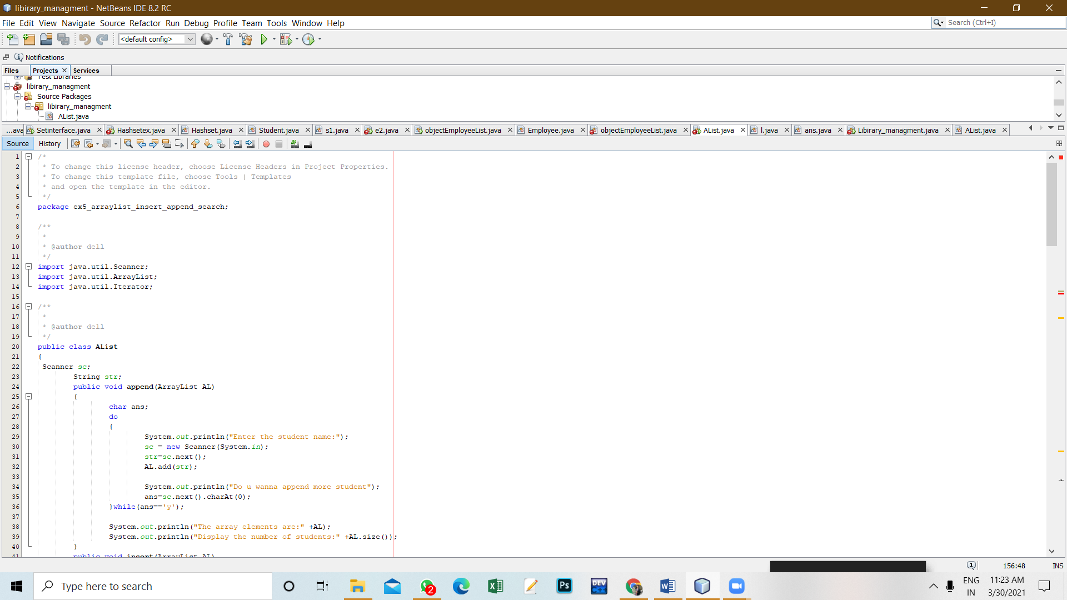

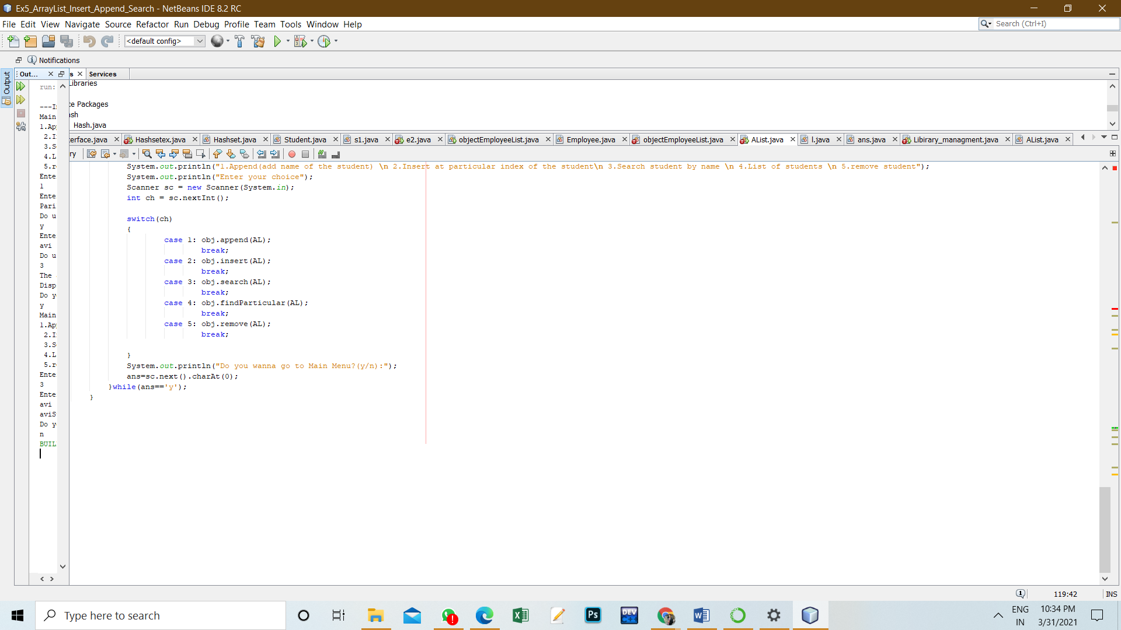

**8. Percentage error (if any or applicable):**

NIL

**9. Calculations/ Chemical Reactions / Theorems /Formulas used etc :**

NIL

**10. Result/Output/Writing Summary:**

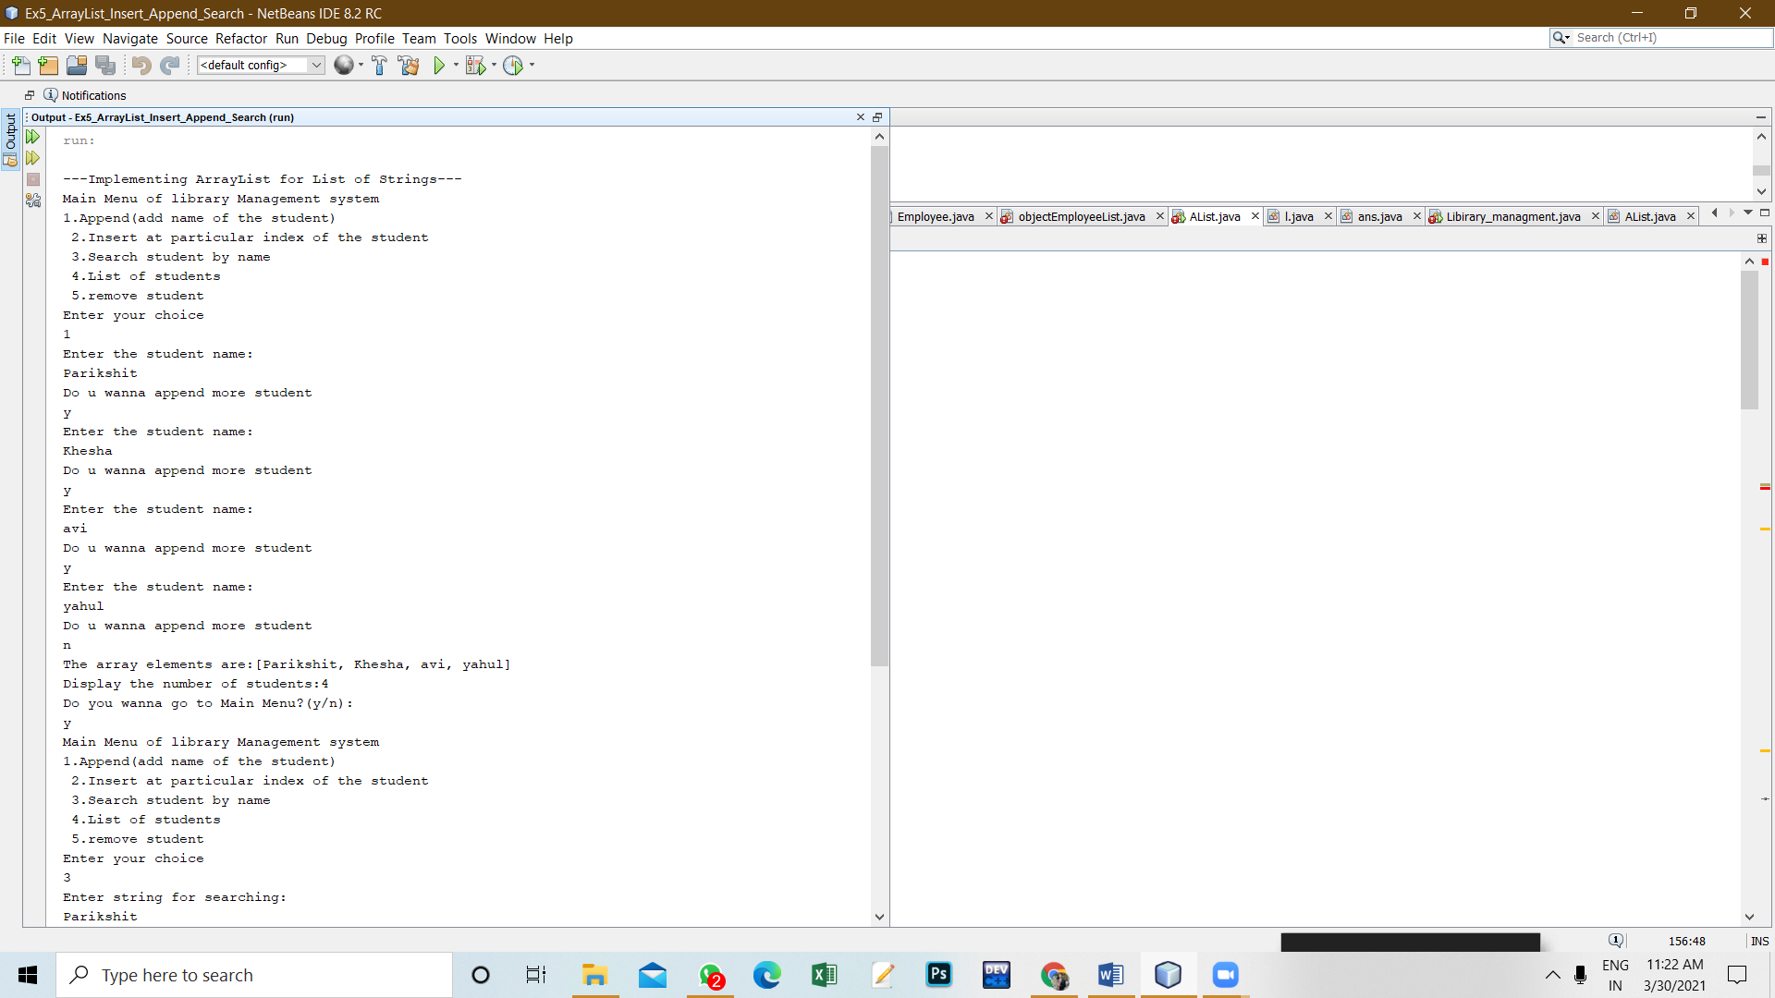

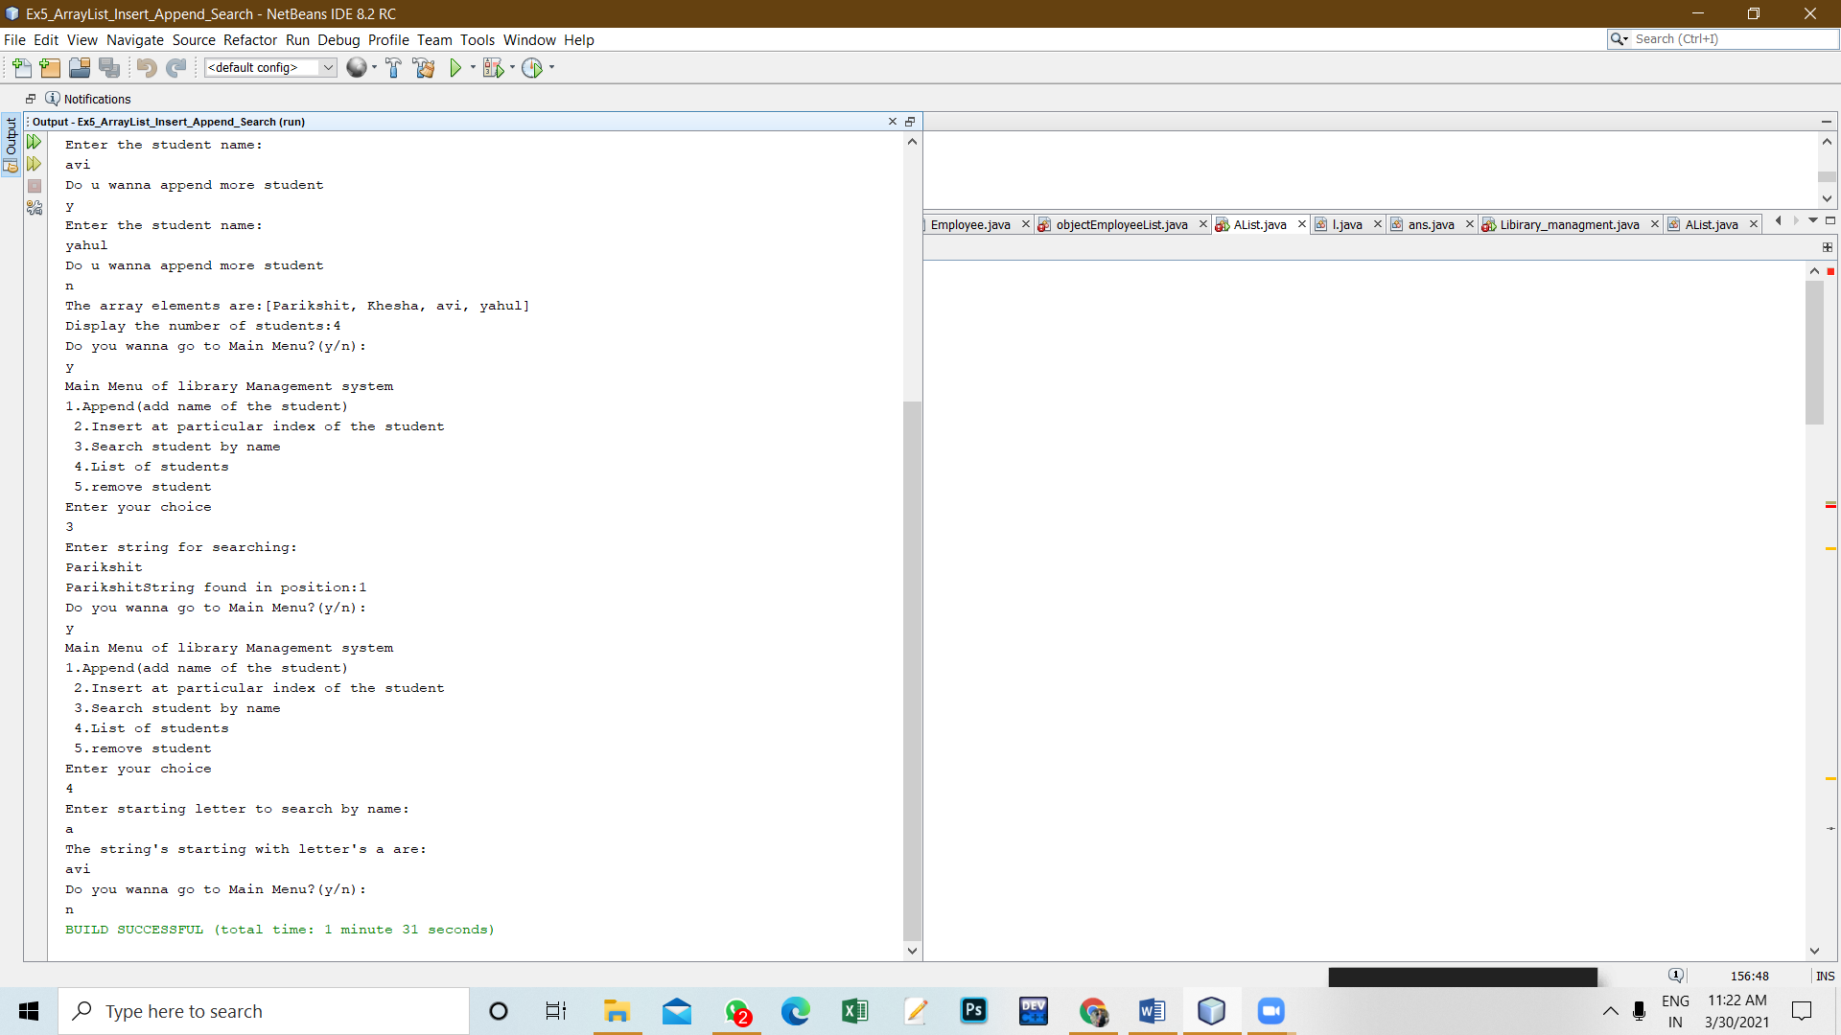

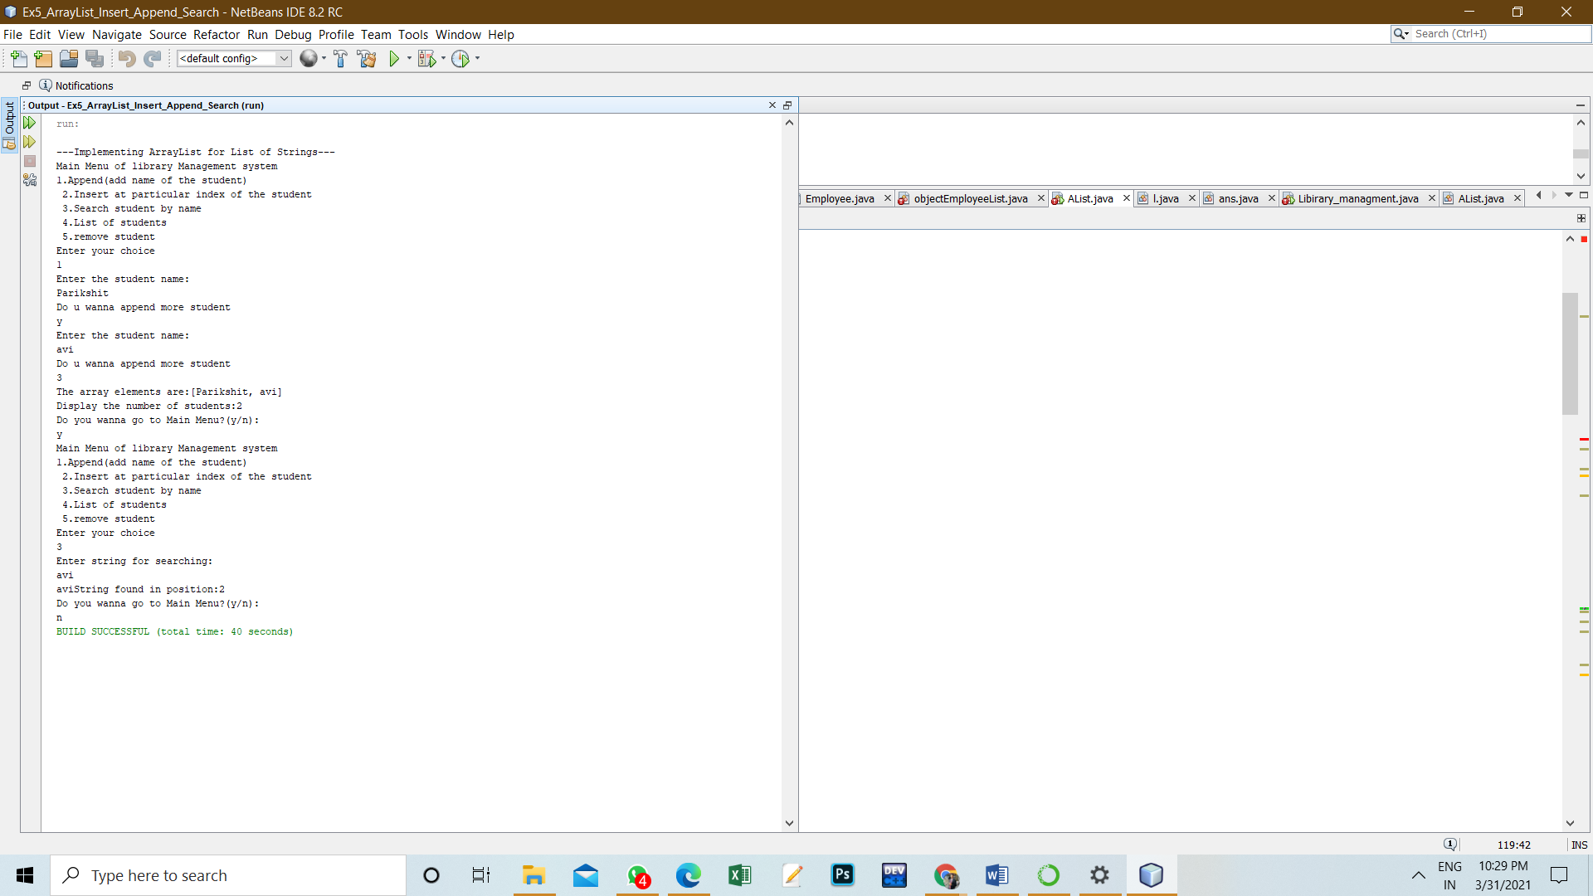

**`**

**11. Graphs (If Any): Image /Soft copy of graph paper to be attached here:NIL**

**Learning outcomes (What I have learnt):**

1. Learnt to write a java program.

2. Learnt to write an effective algorithm.

3. Learnt to implement the Array List in java.

4. Learnt to add, delete , display and search in an Array List.

**Evaluation Grid (To be created as per the SOP and Assessment guidelines by the faculty):**

|  |  |  |  |
| --- | --- | --- | --- |
| Sr. No. | Parameters | Marks Obtained | Maximum Marks |
| 1. |  |  |  |
| 2. |  |  |  |
| 3. |  |  |  |
|  |  |  |  |